City Council Briefing
November 21, 2022
Objective 1. Community Outreach and Public relations
- Kick’n it with the Cops October 28-29
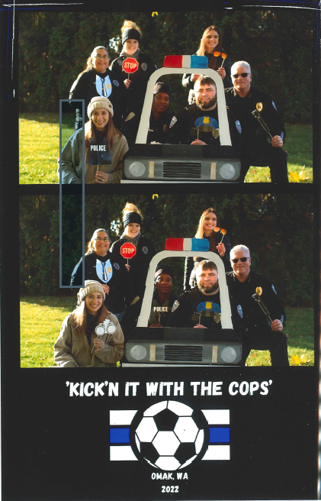
- Excellent turn out ~300+ Friday evening (Thanks to Wayne)
- Saturday event excellent with good community engagement
- Many thanks to our community sponsors
- CORE program, Rochelle
- Community outreach, Georgia Lamb
- PD, Courtney, Susie, Aaron, Dustin
- Our entire City team helped from Clerk to Public Works and the Mayor
- We will be going over on our advertising budget as set, however this is more than offset by $5,610.00 in revenue that we generated through donations.
- We received even more donations of product, snacks, and books
- It was really a terrific program

Objective 2. Crime trends and major investigations

- Holding at 17% above last year overall

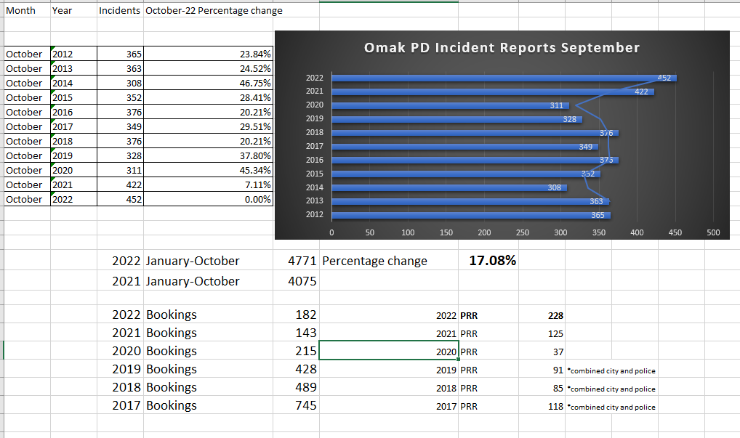

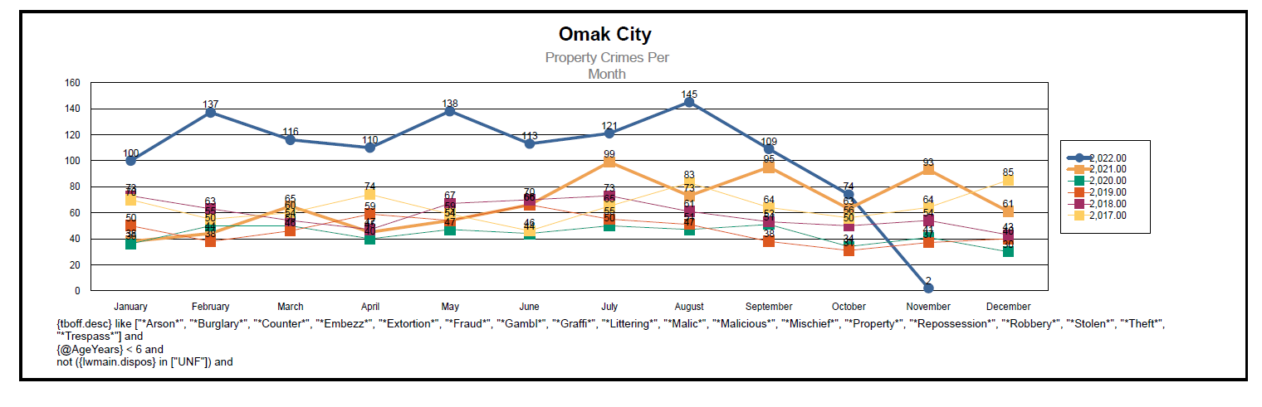

Objective 3. Human resource issues and personnel actions (Recruitment, Retention, Onboarding, Offboarding, career development progression).
- Josiah Lamb is doing very well excellent public feedback.
- Sheriff’s Office is currently offering a $10,000.00 hiring bonus
- We presently have one open funded vacancy for patrol
- Recruitment practices are becoming very important in todays climate.

Objective 4. PUBLIC SAFETY, Developing improved partnerships with our Community Safety Teams. (New Objective) work in progress

Objective 5. Education and Schools

Objective 6. Commercial Criminal Activity
- Shoplifting continues to be an issue, no different in other jurisdictions
- Flock camera systems conducted a presentation for a few businesses that attended a meeting to pilot the technology.
- Theft and resources to prosecute will continue for the near future.
- Businesses need to invest in security and technololgy. We do not hold the staffing levels to support all that is requested.

Objective 7. National/State/County trends.
- A fentanyl vaccine-

