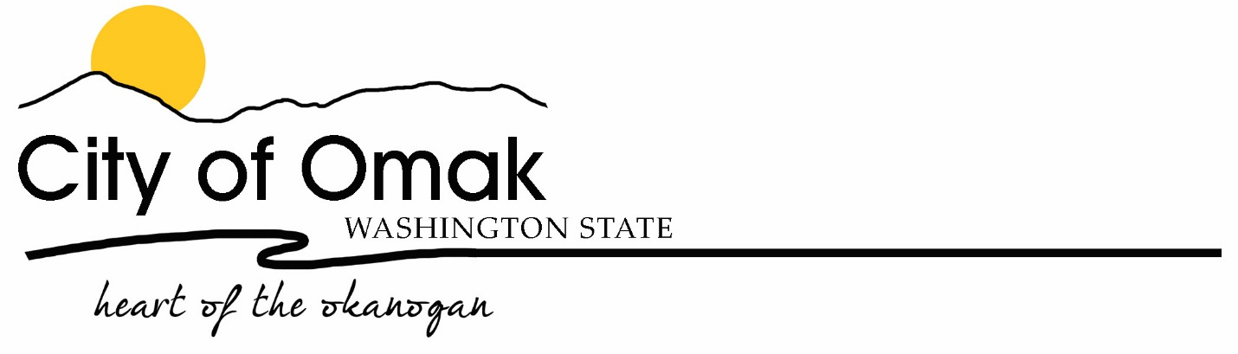
LANDLORD’S REQUEST FOR TENANT
City of Omak,

I, ____________________________, being the owner of the property at the below mentioned property am notifying the City of intent to rent my property. I am hereby requesting that my tenant (listed below) receives a copy of the utility bill for water, sewer, and garbage services.

I understand that in the event the renter / tenant moves out of the property and leaves an unpaid balance on the utility account, as the owner of the property, I am responsible for payment of the unpaid balance. I further understand that any balance left owing on the utility bill for the city of Omak constitutes a lien against the property, and services will not be reinstated until the balance and lien are paid in full.

In the event the below named tenant vacates the property, I understand that it is my responsibility to notify the City.

PROPERTY ADDRESS

__________________________________ , OMAK, WA 98841 ACCOUNT NUMBER: _______________

OWNER INFORMATION RENTER / TENANT INFORMATION

NAME: __________________________________ NAME: _____________________________________

MAILING ADDRESS: ________________________ MAILING ADDRESS: ___________________________

________________________ ___________________________

PHONE NUMBER: __________________________ PHONE NUMBER: _____________________________

SIGNATURE: ______________________________ MOVE IN DATE: __________________

DATE: ________________ MOVE OUT DATE: ________________

